Installing the Northwind/Pubs Databases

- First find the zip file in Blackboard that contains the zipped Northwind and pubs databases (same path in Blackboard where you clicked to find this document). Once downloaded, unzip the files and place them in the following folder:
C:\Program Files\Microsoft SQL Server\MSSQL13.MSSQLSERVER\MSSQL\DATA
Note that your exact path may differ slightly based on where your program files are located.
- Open SQL Server Management Studio. If using a virtual machine, it will be located on your Desktop. If you have difficulty finding where it is installed (and not using the virtual machine), try looking under All Programs or using the Search tool.
- Right-click Databases and select Attach…
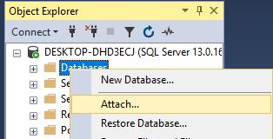
- Click on Add.
- Browse out to either the Pubs or Northwind MDF file (database file). Note that whichever one you choose, you will have to repeat the process to add the second database (you can only attach one at a time). When selecting the files, navigate to the path where you placed the files in Step 1.

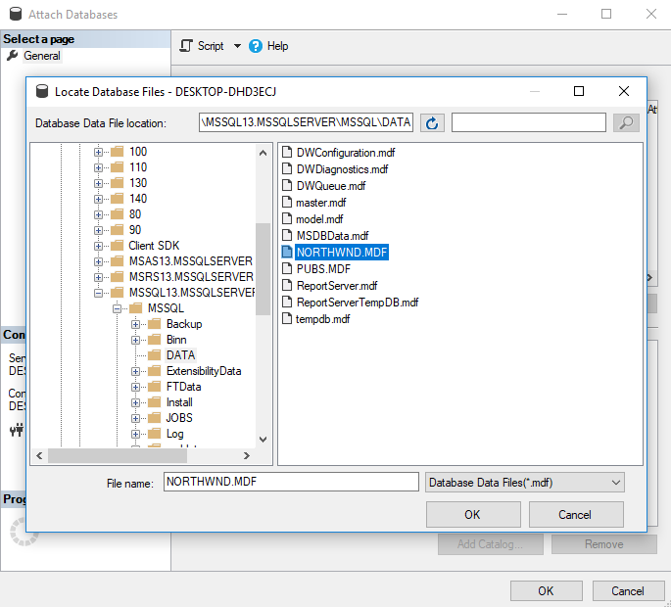
6. Click OK to ensure the selected MDF file is correct.
7. Click OK once more.
8. Once you complete this process for both databases, the Northwind and Pubs sample databases should be listed: 